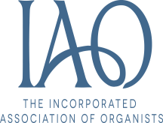
NEWBURY & DISTRICT ORGANISTS’ ASSOCIATION
Annual General Meeting – Saturday 23rd February 2019 at 2.30pm
St Matthew's Church, Church Hill, Midgham, RG7 5UW
- Present:

- Welcome:

- Apologies for Absence:

- Minutes of the Previous Meeting:

- Matters Arising:

- Chairman’s Report:

- Secretary’s Report:

- Treasurer’s Report:

a)Acceptance of the Annual Accounts:
b)Subscription Ratification:

- Membership Secretary’s Report:

- Webmaster’s Report:

- Social Secretary’s Report:

- Election of Officer’s and Committee Members:

Chairman:

Secretary:

Treasurer:

Membership Secretary:

Webmaster:

Committee Members:

- Appointment of Independent Examiner:

- Any Other Business:

