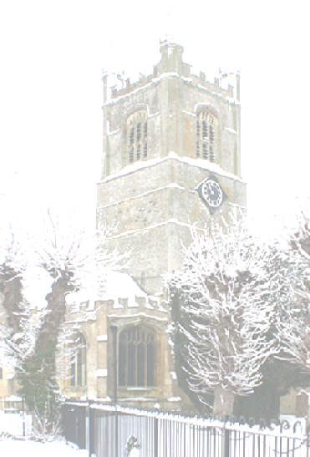

Lambourn Church Choir
and Friends

Good Friday Concert
Conducted by Stephen Holmes
Friday 3rd April 2015 at 7.30pm
Bach – Christ Lay in Death’s Dark Prison
Mozart – Solemn Vespers
Organ accompaniment - Sylvia Ardron

Organ music by Bach, played by
Stephen Holmes

Retiring collection in aid of Church Funds

